Why Use HSV?

Monitors (and therefore computers) and other systems that emit light use the RGB (Red / Green / Blue) colour model. This is called additive colour mixing because the more you add of each component colour, the brighter the colour you get (white being the maximum of red, green & blue).

This is fine for most applications but if you want to do some fancy effects it is often worth considering other colour models (or colour spaces).

What is HSV?
The HSV colour space is a more 'arty' system based on the colour wheel. Instead of defining the colour by values of Red, Green & Blue, it uses Hue, Saturation & Value:
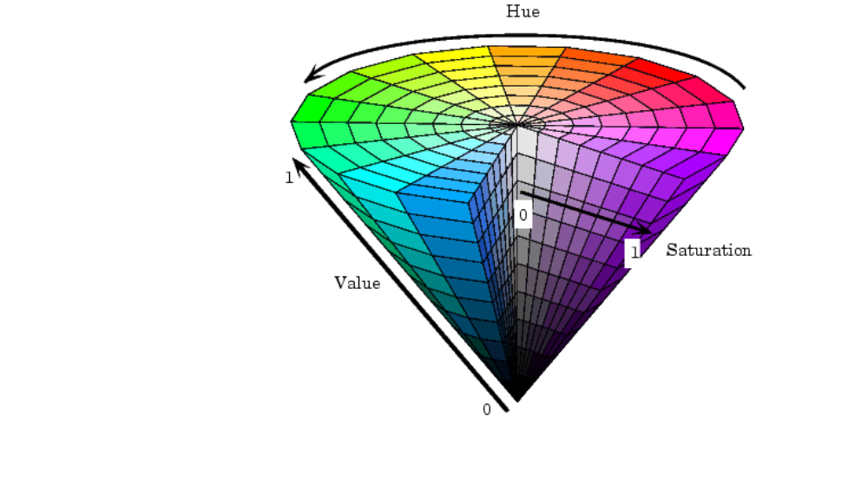(Source of diagram unknown!)

Hue is the angle around the colour wheel which gives us the colour. Some examples are listed below:
Colour | Degrees
Red | 0
Yellow | 60
Green | 120
Cyan | 180
Blue | 240
Magenta | 320

Saturation is the distance from the centre of the colour wheel. A colour with S=0 is totally white, a colour with S=1 has no white at all and lies at the very edge of the colour wheel.
Value is the brightness of a colour. The higher the Value, the brighter the colour. V=0 is black; V=1 is a very brilliant colour.

Some Uses of HSV

hsvDemo1.bb
Because the hue (colour) is represented by a single value it makes it very easy to filter out certain colours regardless of their brightness. This allows you to change one colour to another by adding/subtracting the difference in Hue. For example, you can have one set of sprite graphics and dynamically build a new set for each player in a different colour (even a colour selected by the players themselves).

hsvDemo2.bb
Also, because it uses the colour wheel, it is a very useful for determining contrasting and complementary colours. The opposite colour on the colour wheel is a good contrasting colour. The colours either side (30 degrees) of the opposite make good complementary colours.

HsvDemo3.bb
HSV is also essential for doing any kind of palette functionality. This third demo displays a colour wheel for the Hue & Saturation with an additional bar for the Value. The HSV & RGB values of the selected colour are also displayed.

Please look at the example code to see how these work...

Other Uses
I’m sure you can think of many other uses for this colour system. Please post any ideas you have on www.aurora-soft.co.uk.

Using the Colour Space Library

Simply include the colourSpace.bb file in your Blitz Basic program. Please refer to colourSpace.bb file for details of each function.

The demo files detailed above, not only show you some of the uses of HSV, but they also show you how to implement the functions into your Blitz programs.

Have fun…

Ghost Dancer

